DELV-16469_Hardware Governance Dashboard validation :

1. Hardware Devices(Total Devices) : Sum(Registered Devices) + (Un Registered Devices).

The respective assets will be repeated in the Total Devices.

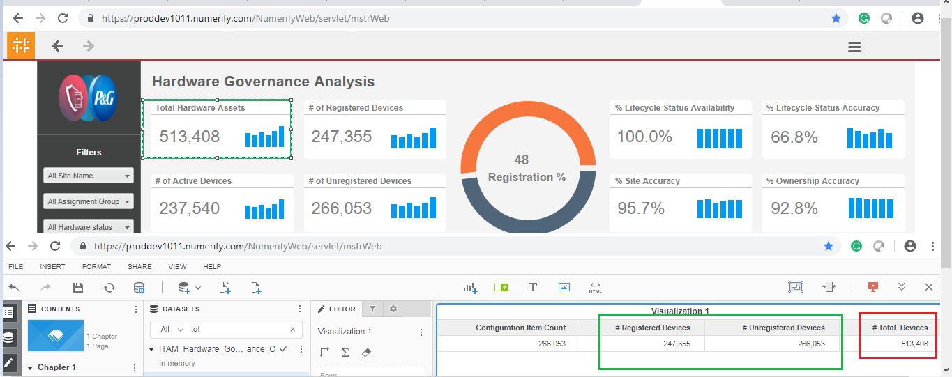

1. Unregistered Application : Count is not matched with source.

